Activity | Data Type
Number of beatings from Wife | Discrete data
Results of rolling a dice | Discrete data
Weight of a person | Continuous data
Weight of Gold | Continuous data
Distance between two places | Continuous data
Length of a leaf | Continuous data
Dog's weight | Continuous data
Blue Color | Discrete data
Number of kids | Discrete data
Number of tickets in Indian railways | Discrete data
Number of times married | Discrete data
Gender (Male or Female) | Discrete data
Q1) Identify the Data type for the Following:

Q2) Identify the Data types, which were among the following
Nominal, Ordinal, Interval, Ratio.
Data | Data Type
Gender | Nominal
High School Class Ranking | Ordinal
Celsius Temperature | Interval
Weight | Ratio
Hair Color | Nominal
Socioeconomic Status | Ordinal
Fahrenheit Temperature | Interval
Height | Ratio
Type of living accommodation | Nominal
Level of Agreement | Ordinal
IQ(Intelligence Scale) | Ratio
Sales Figures | Ratio
Blood Group | Nominal
Time Of Day | Nominal
Time on a Clock with Hands | Nominal
Number of Children | Ratio
Religious Preference | Nomial
Barometer Pressure | Ratio
SAT Scores | Nominal
Years of Education | Ratio

Q3) Three Coins are tossed, find the probability that two heads and one tail are obtained?
Ans) The probability of obtaining two heads and one tail when three coins are
tossed is 3/8.
P(two heads and one tail)=p(HHT)+p(HTH)+p(THH)=1/8+1/8+1/8=3/8
Q4) Two Dice are rolled, find the probability that sum is
- Equal to 1
- Less than or equal to 4
- Sum is divisible by 2 and 3

Ans) a) The probability is 0
b) Probability is 1/6
C) Probability is 5/36

Q5) A bag contains 2 red, 3 green and 2 blue balls. Two balls are drawn at random. What is the probability that none of the balls drawn is blue?

Ans) The probability that none of the balls drawn is blue is 10/21

Q6) Calculate the Expected number of candies for a randomly selected child
Below are the probabilities of count of candies for children (ignoring the nature of the child-Generalized view)
CHILD | Candies count | Probability
A | 1 | 0.015
B | 4 | 0.20
C | 3 | 0.65
D | 5 | 0.005
E | 6 | 0.01
F | 2 | 0.120
Child A – probability of having 1 candy = 0.015.
Child B – probability of having 4 candies = 0.20
Ans) The expected number of candies for a randomly selected child is 3.09
E(X)=(1*0.015)+(4*0.20)+(3*0.65)+(5*0.005)+(6*0.01)+(2*0.120)
E(X)=0.015+0.08+1.95+0.025+0.06+0.24
E(X)=3.09

Q7) Calculate Mean, Median, Mode, Variance, Standard Deviation, Range & comment about the values / draw inferences, for the given dataset
- For Points,Score,Weigh>
Find Mean, Median, Mode, Variance, Standard Deviation, and Range and also Comment about the values/ Draw some inferences.
Use Q7.csv file
Answers:-
Mean Points: 3.5965625
Mean Score: 3.2172500000000004
Mean Weight: 17.848750000000003
Median Points: 3.6950000000000003
Median Score: 3.325
Median Weight: 17.71
Mode Points: 3.07
Mode Score: 3.44
Mode Weight: 17.02
Variance Points: 0.27694755859375
Variance Score: 0.927460875
Variance Weight: 3.0933796874999997
Standard Deviation Points: 0.526258072236189
Standard Deviation Score: 0.9630477013107918
Standard Deviation Weight: 1.758800638929836
Range Points: 2.17
Range Score: 3.9110000000000005
Range Weight: 8.399999999999999

Q8) Calculate Expected Value for the problem below
- The weights (X) of patients at a clinic (in pounds), are
108, 110, 123, 134, 135, 145, 167, 187, 199
Assume one of the patients is chosen at random. What is the Expected Value of the Weight of that patient?
Ans)1/9(108+110+123+134+135+145+167+187+199)
1/9(1308)=145.33
E(X)=145.33

Q9) Calculate Skewness, Kurtosis & draw inferences on the following data
Cars speed and distance
Use Q9_a.csv

SP and Weight(WT)
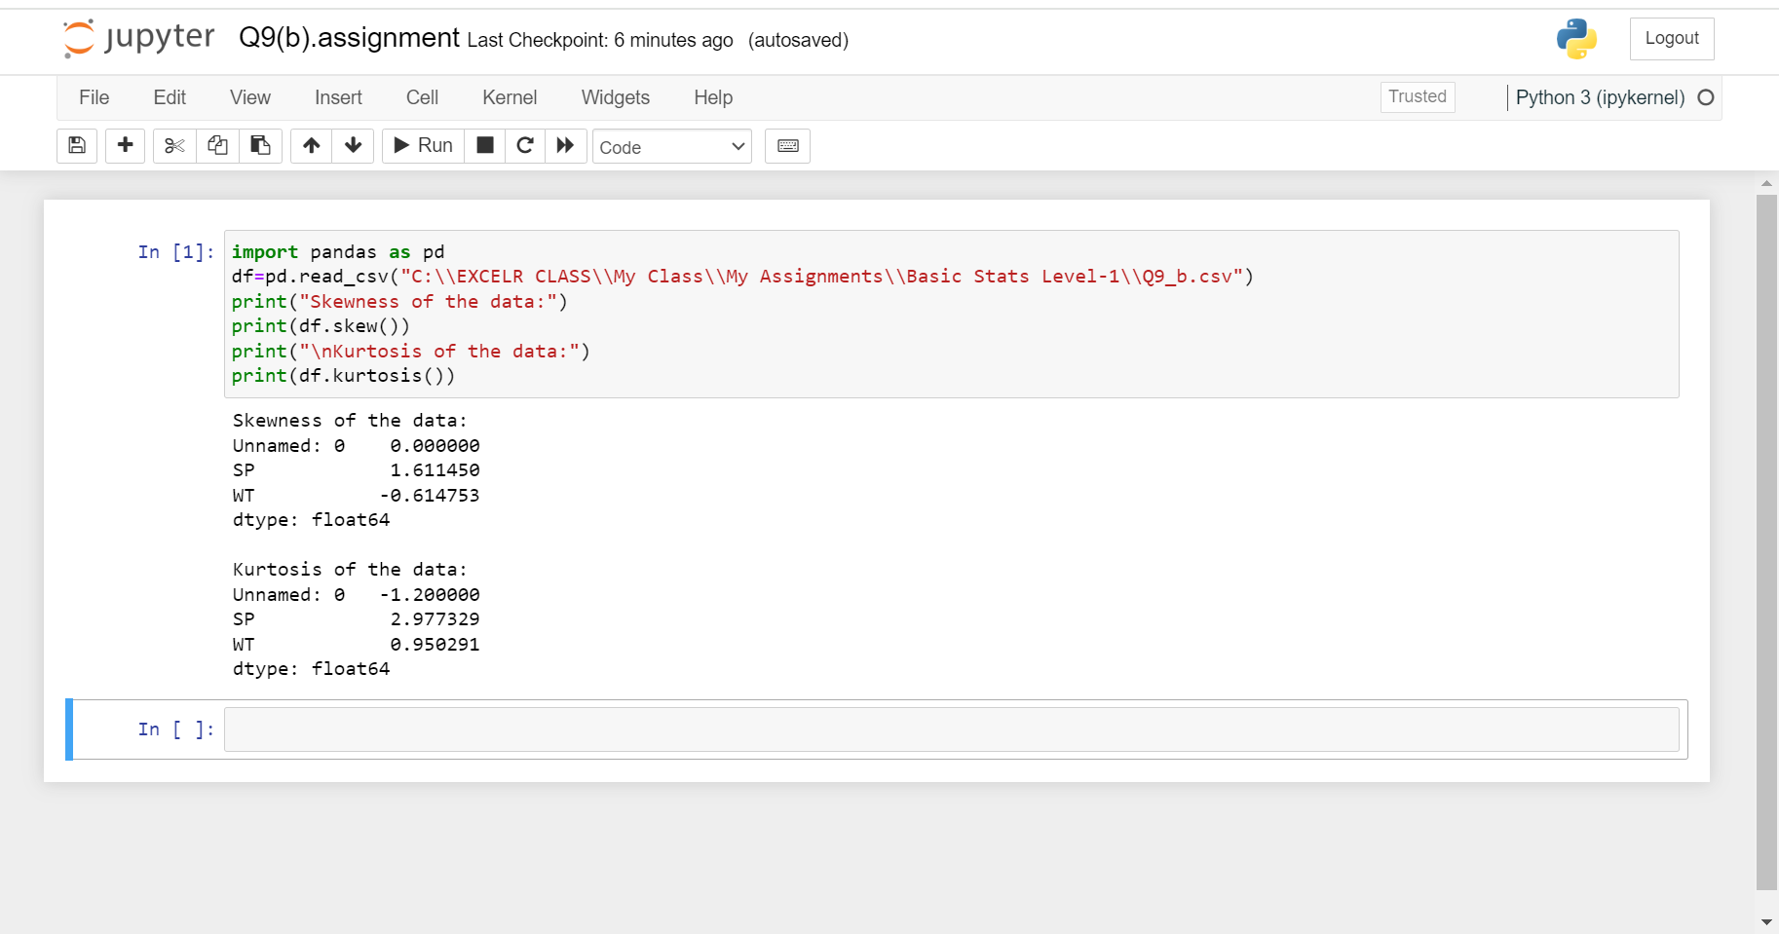
Use Q9_b.csv
Answers:-
Inferences :
Cars speed:
The data is slightly positively skewed, indicating that there are a few cars with higher speeds compared to the majority.
The data is platykurtic (less peaked than a normal distribution), suggesting that the distribution is spread out with fewer outliers.

Cars distance:
The data is moderately positively skewed, implying that there are more cars with longer distances compared to the majority.
The data is mesokurtic (similarly peaked to a normal distribution), indicating that the distribution is relatively symmetrical.
Q10) Draw inferences about the following boxplot & histogram

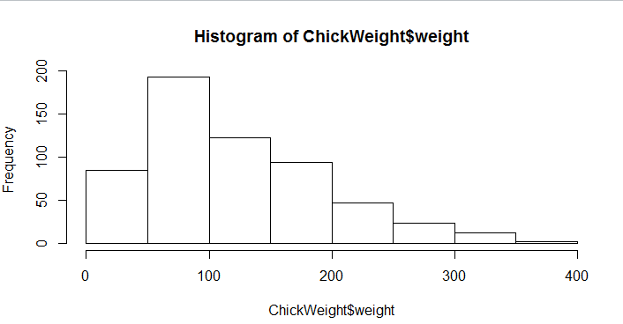
Ans) The graph is Right Skewed
Skewedness = positive
Most of the values are left side
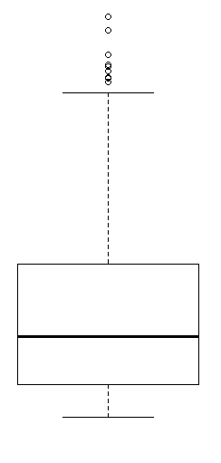
Ans) The data has outliers
It is positively skewed
Q11) Suppose we want to estimate the average weight of an adult male in Mexico. We draw a random sample of 2,000 men from a population of
3,000,000 men and weigh them. We find that the average person in our sample weighs 200 pounds, and the standard deviation of the sample is 30 pounds. Calculate 94%,98%,96% confidence interval?
Ans) The 94% confidence interval is(198.737, 201.263)
The 96% confidence interval is(198.6839, 201.3161)
The 98% confidence interval is(198.4332, 201.5668)
Q12) Below are the scores obtained by a student in tests
34,36,36,38,38,39,39,40,40,41,41,41,41,42,42,45,49,56
- Find mean, median, variance, standard deviation.
Ans)Mean=41,Median =40.5,Variance=59.89,Standard deviation =7.74
- What can we say about the student marks?
Ans) The student's marks exhibit a moderate spread around the mean, with a variance of approximately 59.89 and a standard deviation of about 7.74. This suggests a degree of variability in the scores, indicating that the student's performance is not consistently close to the mean.
Q13) What is the nature of skewedness when mean, median of data are equal?
Ans) Symmetric & zero Skewedness
Q14) What is the nature of skewedness when mean > median ?
Ans) Positively Skewed
Q15) What is the nature of skewedness when median > mean?
Ans)Positively Skewed
Q16) What does positive kurtosis value indicates for a data ?
Ans)Heavier tails and a more peaked distribution (Kurtosis>0)
Q17) What does negative kurtosis value indicates for a data?
Ans)lighter tails and a flatter distribution(kurtosis<0)
Q18) Answer the below questions using the below boxplot visualization.
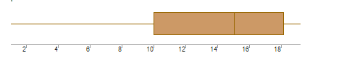
What can we say about the distribution of the data?
Ans)lighter tails and a flatter distribution(kurtosis<0)
What is nature of skewedness of the data?
Ans)Left Skewed
What will be the IQR of the data (approximately)?
Ans) IQR is 8
Q19) Comment on the below Boxplot visualizations?
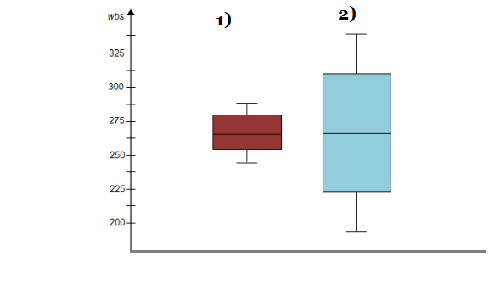
Draw an Inference from the distribution of data for Boxplot 1 with respect Boxplot 2.
Ans) Data is normally distributed
There are no outliers
262 is the center and both graphs has different ranges
Q 20) Calculate probability from the given dataset for the below cases

Data _set: Cars.csv
Calculate the probability of MPG of Cars for the below cases.
MPG <- Cars$MPG
  - P(MPG>38)
Ans) 0.40740
  - P(MPG<40)
Ans) 0.75308
c. P (20<MPG<50)
Ans)0.85185

Q 21) Check whether the data follows normal distribution
- Check whether the MPG of Cars follows Normal Distribution
Dataset: Cars.csv
Ans) MPG is following normal distribution

- Check Whether the Adipose Tissue (AT) and Waist Circumference(Waist) from wc-at data set follows Normal Distribution
Dataset: wc-at.csv
Ans) Both AT and waist is not following the normal distribution

Q 22) Calculate the Z scores of 90% confidence interval,94% confidence interval, 60% confidence interval
Ans)90%=1.711
94%=1.828
60%=2.492
Q 23) Calculate the t scores of 95% confidence interval, 96% confidence interval, 99% confidence interval for sample size of 25
Ans) 95%=2.060
96%=2.167
99%=2.787
Q 24) A Government company claims that an average light bulb lasts 270 days. A researcher randomly selects 18 bulbs for testing. The sampled bulbs last an average of 260 days, with a standard deviation of 90 days. If the CEO's claim were true, what is the probability that 18 randomly selected bulbs would have an average life of no more than 260 days
Hint:
rcode → pt(tscore,df)
df → degrees of freedom
Ans) T score=-0.4714
Degree of freedom=17
P(1)=0.32167

